Top Tips if Having Children at your Wedding
Are you inviting children to your wedding or not? One of the biggest questions when planning a wedding. Children can bring a magic atmosphere to your wedding celebration but can mean their parents don’t get to fully enjoy the day.
If you decide to have children at your wedding take care of them by offering some entertainment.
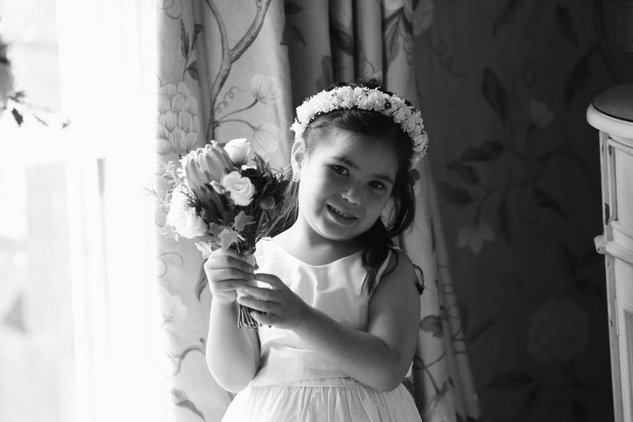
Decide on whose children are invited: It’s perfectly acceptable to just invite children of both families & perhaps even just to the ceremony where some of them will be part of the wedding party. Get the word out well in advance so parents can plan either way. You will find that lots of parents will be very happy that they are not expected to bring their children so they can have a care free day out!

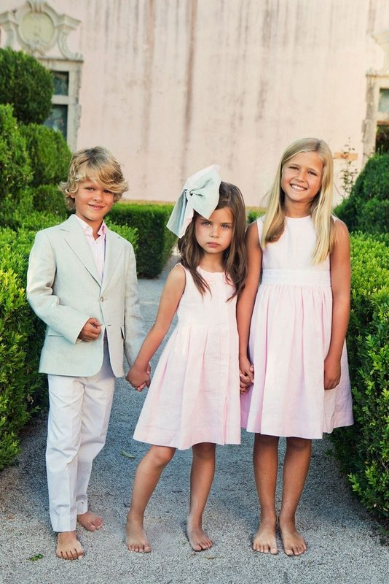

If Children Attending Dinner: You can put children at the same table of their parents during the reception or if there are some older children one table for all children is an idea to consider. If no older children perhaps a babysitter to keep an eye on the children during dinner & afterwards.
Food: While most children will eat the traditional burger & fries or sausage some parents may prefer their children to dine on more healthy options such as potato & vegetables. If you c an just ask your venue to ensure to have both options available. Serve ice cream dessert as every child likes it! Serve some soft drinks, water and juice during the reception for the children.

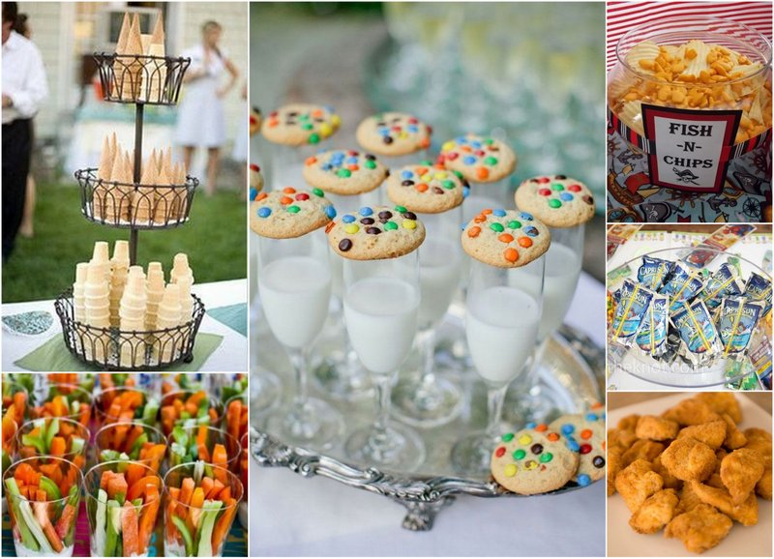

Entertainment: All children like to be entertained & remember happy children leads to happy adults! Some ideas to consider:
- If you have your reception in a venue with gardens, you could have traditional games such as Twister, hopscotch, skipping... Games kids may not play too much but are loved by children for generations.

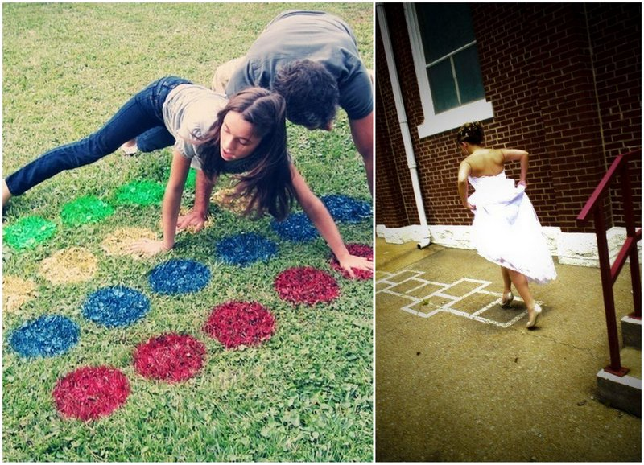
- If you have your reception in a venue without outside spaces, take some board games to divert kids during the reception like Monopoly, Guess Who, Cluedo...

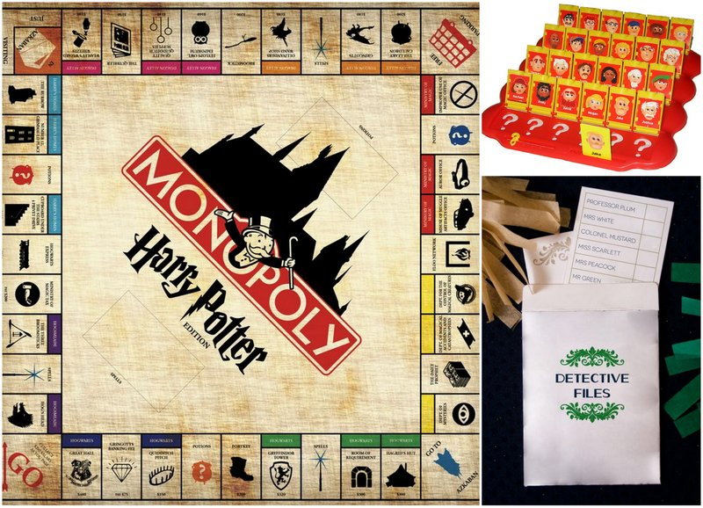
- If the venue allows, have a movie room at your disposal. Kids like watching movies and eating popcorn as if in a cinema. Good idea to have some comfortable pillows, cushions. & bean bags. This could be the end of the evening activity before children go to bed.

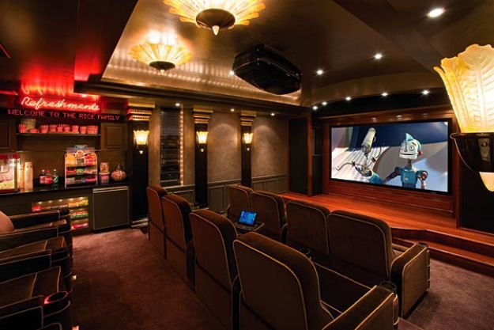
- Create an artistic area as lots of children are really creative like drawing and creating new things. Provide crayons and craft supplies like stickers, playdough... They can even make some cards for the bride & groom or decorate your photobooth...

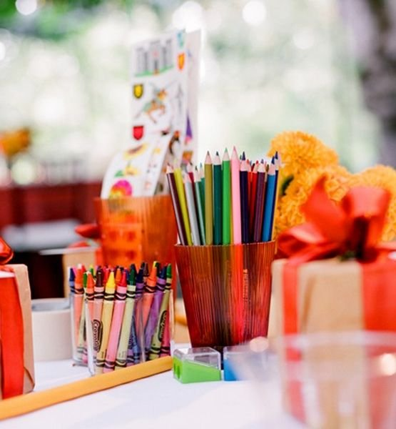
- Entertainers: Clowns are a great option for entertaining children during a wedding reception. They will ensure the children are entertained for an hour /two with games, music & face painting.

Be cool & relaxed: By inviting kids to your wedding, you must be aware they will bring some surprise moments as they are spontaneous and carefree. If one of them tries to touch the wedding cake you no need to get angry, instead laugh and take a picture of it.
Gift: To avoid any conflicts between kids, give exactly the same gift to everyone. Give each one a goody bag at their place setting during the reception with items such as crayons, books, juices, toys, bubbles and biscuits.

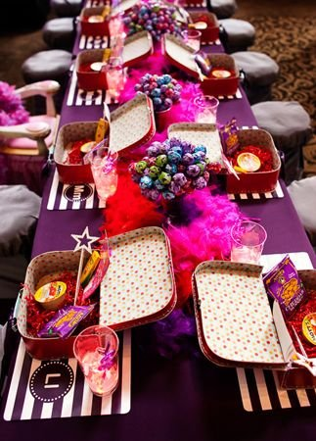
Tricky situations: Be careful of children during the ceremony and the speeches... For speeches, perhaps have the babysitter take them out of the room to play area /watch a movie.
- Babysitter: Even if you are inviting children to the reception you might like to encourage parents to book a babysitter for later in the evening when children get tired, she can take them to their rooms for some easy activities such as board games or a movie with some treats! Alternatively the babysitter may take the children as adults sit for dinner to have their party food & fun activities.
Dancing: Lots of kids like dancing so perhaps have some children dance time/tunes after the first dances before they go to bed. Alternatively if you have a number of children attending perhaps have a kids disco separate from the adults earlier in the evening.
